Dog Kennel – Dunstable

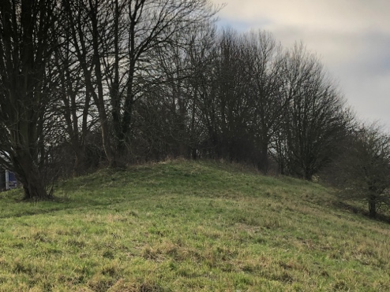
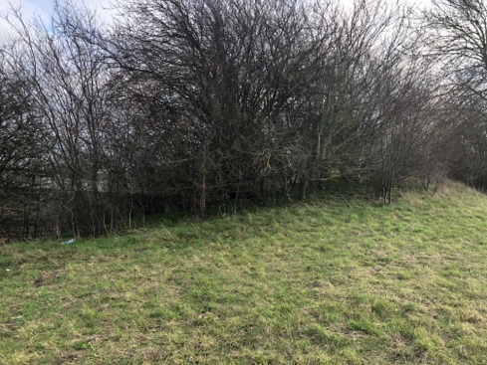
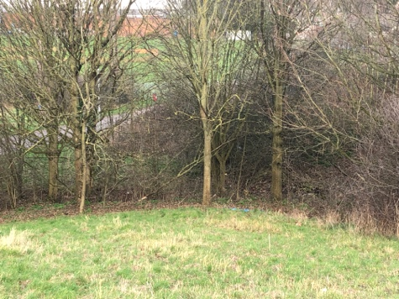
Part of our film ‘Man in Mask’ is going to be shot in a wooded area, for this we decided to use Dog Kennel in Dunstable – a wooded park in Dunstable. When on our reccie, it showed that the area was good place to film, with a little bit of forestry and hills which would be good for our chase scene as it has a creepy atmosphere to it and suits our film well. Here are some photos we took:

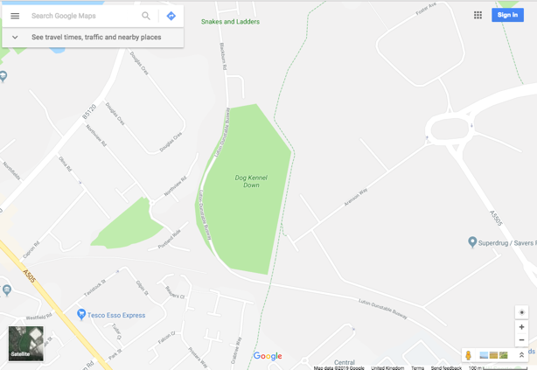
It is located just around the corner from our college so it is easily accessible – just a 5-minute walk from the college. The college car park is only a 5-minute walk as well so if a car was needed somewhere to park they could park there. It is also a 5-10 minutes’ walk from Asda so if food or water was wanted people could get it from there or there are water fountains at the college.

Central Bedfordshire College:

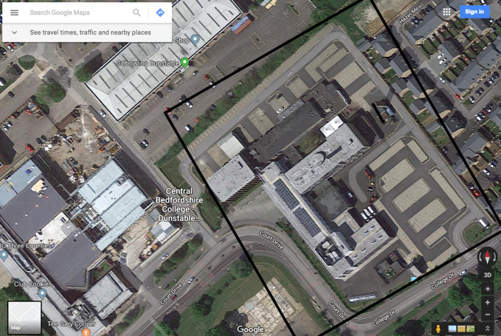
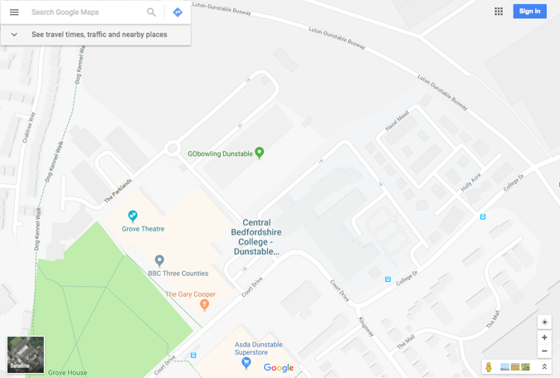
Another part of our film will be using Central Bedfordshire college. Our opening scene starts in an office so we will use our classroom as our ‘office’. We will then use the main entrance doors into the Store for our shot when she’s walking out of the ‘office’. We are also using the college car park for the scenes involving her car.

The College has easy access to water as there are water fountains in most compartments, food accessibility is also easy as Asda is just across the road. With its own car park it is easily accessible for cars.

Houghton Hill Park:

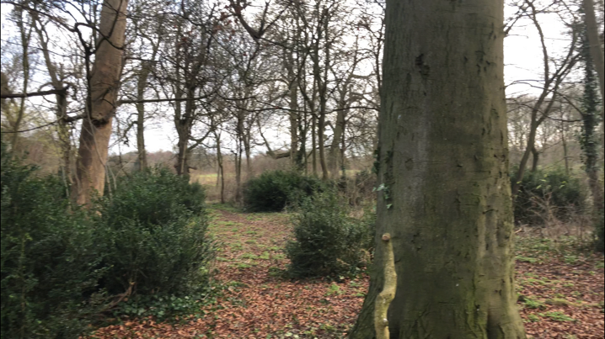
Another place we reccied was Houghton Hill Park, we are looking to use this for parts of our chase scene as well as the Dog Kennel. Here is a photo of the Park.

We felt this was a strong location for our film as its exactly what we pictured when coming up with the idea of a chase scene through a woods, it also adds to the mood and the film with a dark, scary vibe. Which will help create the atmosphere of the film.

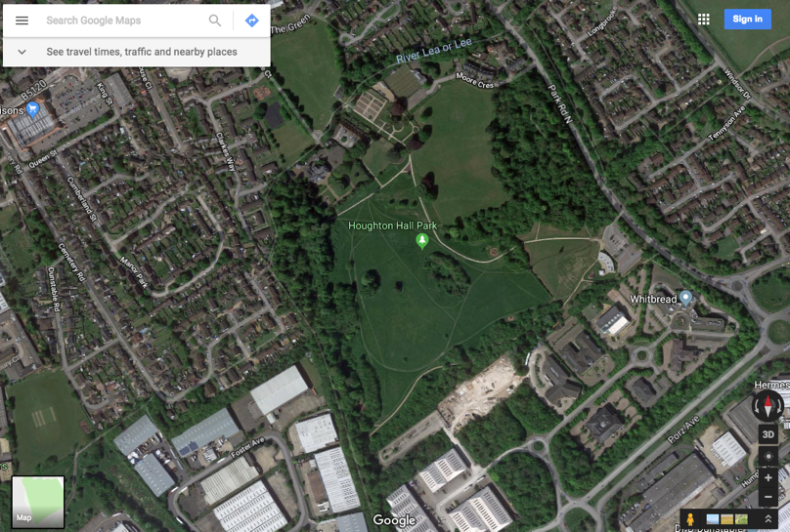
It is located in Dunstable, near Morrisons and about a 10 minutes’ walk from the College. Morrisons could be used a car park and for food and water accessibility.

All of our filming locations are all close together making it easy for us when it comes to production day as it same time between in location shoot and is easily accessible.
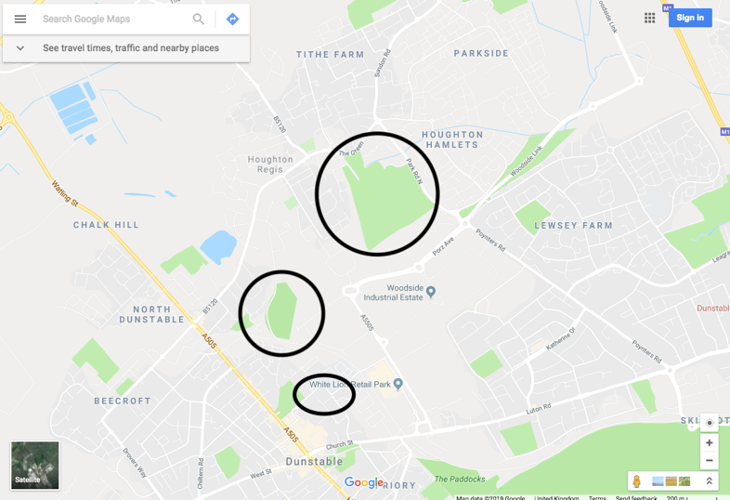

The weather on Friday shows there will be light cloud and a gentle breeze with its highest temperature being 5 degrees, suggesting we should wear warm clothing so we don’t get cold. This weather, if it holds up, will be good for filming as
