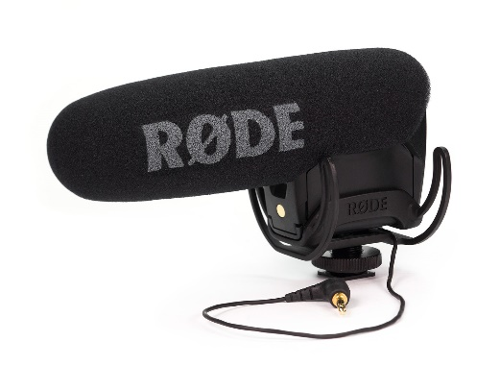
Microphone
Images &
Question
Sheet
By Izzy Munday

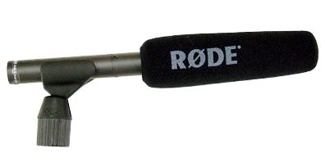
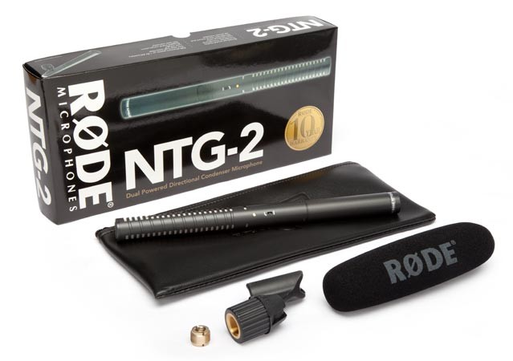

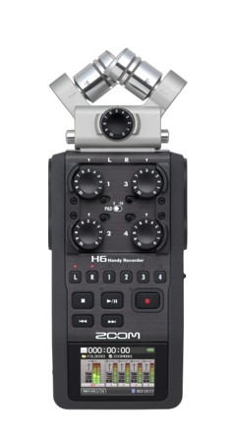
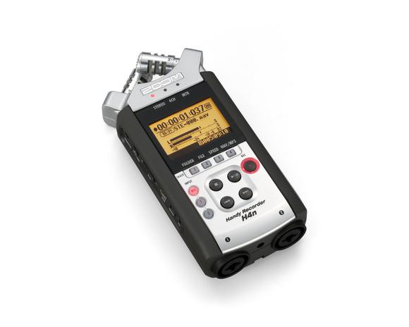

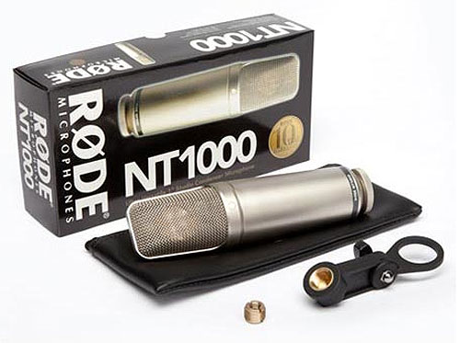
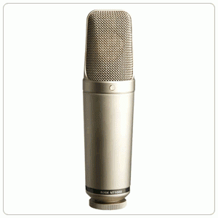
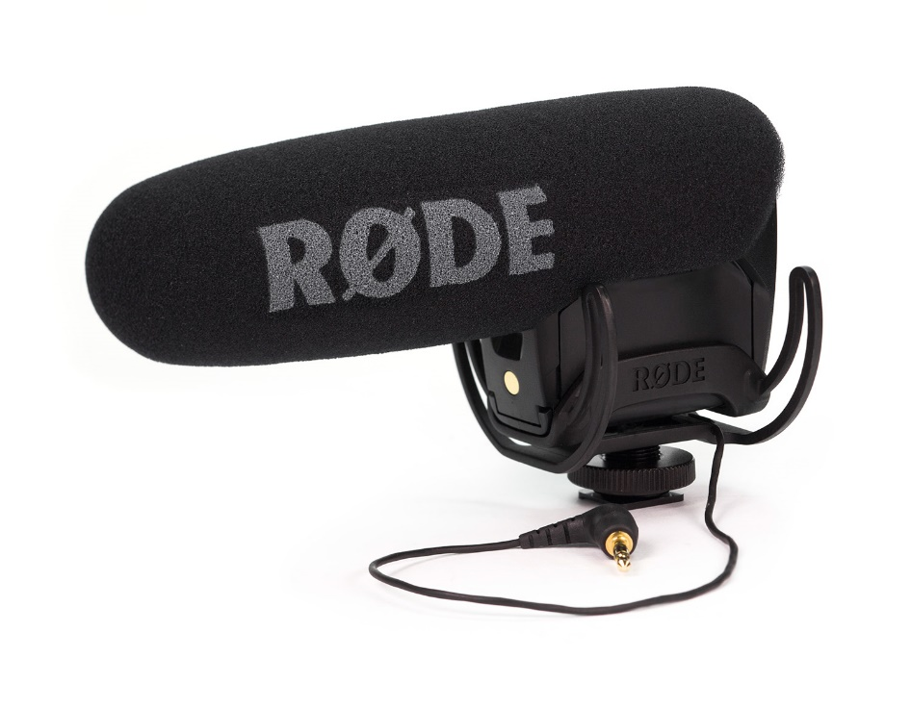
Q: State the name of this microphone
A: VideoMic Pro

Q: How is this microphone powered?
A: Battery powered (9V – over 70 hours use)
Q: What is the name of the pick-up pattern?
A: A super-cardioids polar pattern

Draw a diagram of the pick-up pattern

Mainly pick up audio from the front, minimal audio picked up from the back.

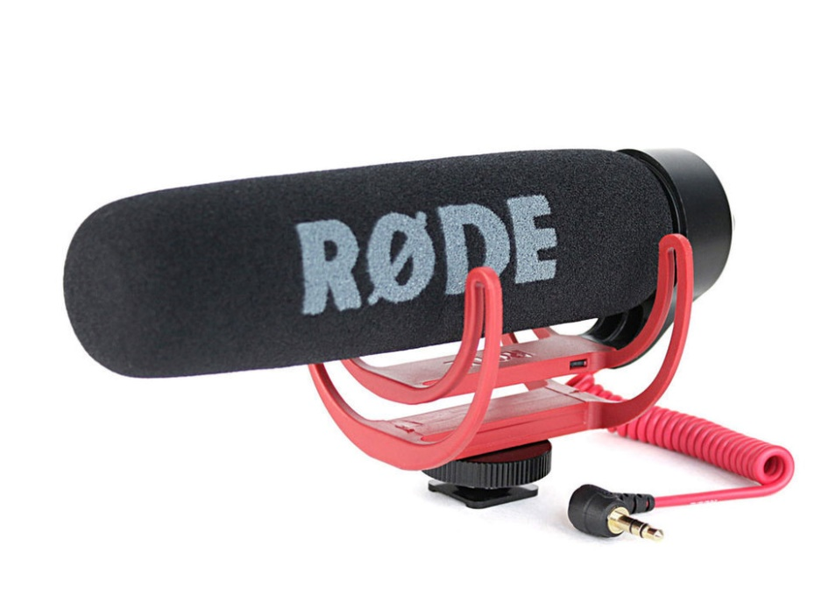
Q: What is the name of this microphone?
A: VideoMic GO

Q: How is this microphone powered?
A: No battery needed, powered by the camera used with it.
Q: What are the differences between this and the microphone above?
A: The Rode Video Mic Pro doesn’t have a battery as its powered by its external microphone input when used in the camera.

Q: What is the name of this microphone?
A: NTG2
Q: How is this microphone powered?
A: P48 phantom power or AA battery option

What is the name of this pick-up pattern?
Supercardioid – picks up the front and sides and rejects 150 degrees to the rear

Draw a diagram of the pick-up pattern

Q: What is the name of this microphone / recording device?
A: Zoom H4n
Q: What batteries does this take?
A: 2 AA batteries

On this twistable X & Y configuration of twin microphones, the numbers listed are 90° and 120° – illustrate what you think this means.
90° & 120°
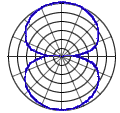

Q: What is the name of this microphone?
A: Rode Nt1000
Q: How is this microphone powered?
A: Phantom Power +24V or +48V

What is the name of this pick-up pattern?
Cardioid – picks up audio from the front and side and rejects the rear.

Draw a diagram of the pick-up pattern
